# Purpose

This paper describes summer 2013 Intern Project.

# Background

Currently the ABB(Totalflow) G4 Product line uses a PC Client based software(PCCU) for local and remote configuration via serial and IP bases connections The purpose of this project will be to develop an android application that will provide a subset of PCCU functions to a field person for access via an IP or Bluetooth connection. This application will not provide all of PCCU functionality but only the features defined in the scope section of this document.

This document will outline the high level user requirements

# Project Objectives

* Provide a user interface via an android device to G4 devices.

# What you should know when you start

We expect you to bring these:

* problem solving skills
* small project, 2 to 4 engineers, 3 months duration, management skills
* basic understanding of Bluetooth wireless protocols
* experience using C++, Java or other object oriented programming language

# What you should learn from this project

We expect you to learn these:

* Software Development Lifecycle
* how to write strong technical requirements
* how to create test procedures
* how to write an Android application
* how to integrate Bluetooth driver into Totalflow uFlo (ARM 9 processor, Windows CE)

# Project Organization

# 

# Roles and Responsibilities

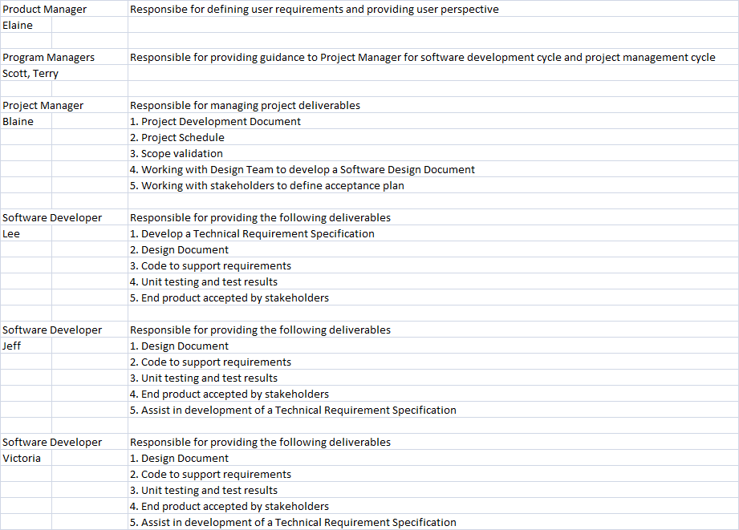

# Project Scope

* Using the android development environment, develop an application that will be used with the current android based mobile phones.
* This application should provide a user interface to the existing G4 product line via Bluetooth or IP connections.
* It should present the data points as defined in the Marketing Requirements with the ability to turn on or off data points for display.
* It should also provide an additional screen with a user defined set of data points not listed in the Marketing requirements.
* It should have a general settings page for general configurations settings such as Communication settings for Bluetooth or IP

# Stretch Scope

* If time allows in the development cycle, provide an option to pull historical data files and configuration files for emailing to possible consumers of these data files.

# Marketing Requirements

* Bluetooth/IP connectivity for an android phone to G4 products (MRS1)
* Default Outputs Option (MRS2)
  + Today’s Flow rate
  + Yesterday’s Flow Rate
  + Today’s Volume
  + Yesterday’s Volume
  + Today’s Energy Rate
  + Yesterday’s Energy Rate
  + Current Alarms
  + Trend for last 14 days of flow
  + Battery Status (Voltage)
  + Charger Status (Voltage)
  + Trend DP pressure
* Optional Outputs Option Complete list is above, but you can turn off others (MRS3)
  + Be able to checklist all of the outputs that you want from the G4
* Screens similar to webpage (MRS4)
* Be able to access from 20 ft away (MRS5)

# Tools

**TCI Tool Kit** – is the API libraries and tools necessary to build, test, and debug G4 uflo connectivity apps

**Android Developer Tools –** Provides everything you need to start developing Android Apps

**Android SDK Tools** – API libraries and developer tools necessary to build, test, and debug Android apps

**G4-uFlo Device** – ABB Flow measurement device

**Bluetooth Adapter** – USB Bluetooth adapter

# References

G4 XRC User manual..

*G:\BVO-ATPA-ALL\CustDoc\Manuals\Manuals-Released\XRC G4 User manual (AA)*

Other User Manuals

*G:\BVO-ATPA-ALL\CustDoc\Manuals\Manuals-Released*

TCI ToolKit

G:\BVO-ATPA-ALL\DV&S\Staging\Work In Progress\2100838-021 (TCI v3.04)